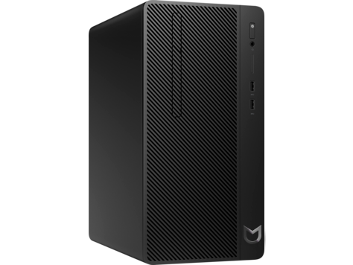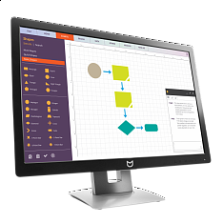

Модель - Irbis H29MTB
Описание - Irbis H29MTB Core i5 8GB/ 500/ Mouse+Keyboard/ Win10Pro/1-1-1/ + 23.8in Monitor

Полные технические характеристики:
N246v 23.8in Monitor EURO
Monitor Bundle (Microtower) 23.8 Packaging
Intel Core i5 8500 3.0 2666MHz 6C 65W CPU
8GB (1x8GB) DDR4 2666 UDIMM NECC Memory
500GB 7200RPM 3.5in
Wired Keyboard RUSS
MT Chassis
Optical USB Mouse
No Included ODD
C13 Straight 1.9m Power Cord RUSS
310W SFF EPA90 FR 115V/230V +12V
1/1/1 (material/labor/onsite) MT Bundle Warranty EURO

